“Woooow….I like it...I like it a lot!” Kofi thought to himself. Kofi’s excitement brought a broad grin to his face. Kofi had just picked up the brand new bike he had been saving for. Kofi was able to buy the bike by saving the extra pocket money he got from doing work around the house plus the money from doing small jobs at a shop near his house.
Kofi wheeled the bike out of the shop hopped on the saddle and pedalled off.

The bike Kofi just bought was the “Super X-11”. Kofi was totally in love at this point, like the bike was his own brand new baby. The bike was a glossy black and it gave off a sparkling shine with the sun reflecting from the chrome detailing as he pedalled. Kofi at this very moment could probably not have been happier. He decided to ride over to the local park where he knew some of his friends would be. He couldn’t wait to show them the bike.

“Simeon come into the living room...,”
“I’m busy mum,”
“Simeon come into the living room right now, before I have to drag you in here, young man”. Simeon dropped his videogame controller and made his way, speedily, to the living room. “What have I done now?” Simeon asked his mum, wary of any sudden movements, ready to duck down or run for it.
“Well young man you have worked conscientiously at school, this term, and received good grades, so I have a surprise for you. Wait here a moment,” mum said, before leaving the room to get Simeon his gift.
Simeon stood waiting in the living room, his mind puzzled as to what conscientious meant and what his gift could be. The excitement and possibilities of an unexpected gift was the winner in his thoughts at this moment, finding out what conscientious meant could wait for later he thought. A large grin developed on his face in anticipation. A few seconds later the grin exploded into giddy laughter. Simeon’s mum entered the living room pushing a gleaming new bike. Simeon walked up to his mum and gave her a hug, one hand on the bike, one hand around his mum. “Thanks mum” he said and gave her a kiss.
“You are welcome my dear, you worked hard for it!” mum replied.
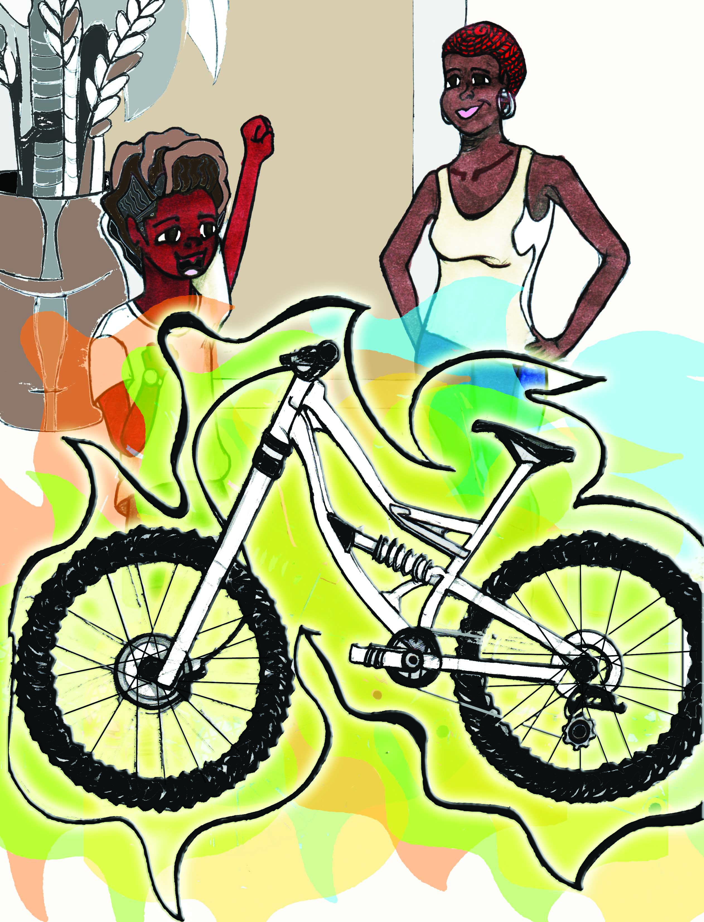

Simeon had been dreaming of owning the beautiful, as he had described it to his mum, “Fox 1000” bike. So he had been regularly saving parts of his pocket money, which he gave to his mum for safe keeping. His plan was to purchase the bike himself once he had saved up enough money. He worked out that his mum had contributed the remaining money needed and bought him the bike.
The Fox 1000 was a snow-white colour, which made it sparkle like ice, “too cool” thought Simeon. He was ecstatic. “Can I take it out for a ride now mum?” Simeon was eager to take the bike out for a ride and to show it to his friends at the park.
Mum replied, “Yes, but be back in time for dinner”,
“No problem,” Simeon shouted back, as he made his way out.

Over at the park a small group of Kofi’s friends were gathered around his new bike, giving it a look over while at the same time testing and admiring the features. The brakes and tyres were squeezed, the saddle was felt, the bike was lifted to check how light it was, and comparisons were made with some of his friends bikes. The group’s general opinion was a mixture of approval and marvel.
“Kofi that bike is baaaad!” said one of the kids.
“You just got it today?” asked another. Kofi was still buzzing with excitement.… “Yeah today, it’s alright” he said in a cool, calm manner, trying not to show how delighted he was with his new bike.

Simeon was making his way to where his friends were in the park, he could see from a distance that there was a small gathering. Nobody noticed Simeon approaching, the group was still marvelling at Kofi’s Super X-11 bike.
Simeon reached the gathering, “Wassup, what’s going on?” he asked. A single head looked up to acknowledge Simeon.
“Hey Simeon how…….what’s that? Is that a….”
“It’s the Fox 1000, man” said Simeon completing his friend’s question.
This caught the ears of some of the group, who looked up abruptly. Some of the kids came over to look at Simeon’s bike and questioning murmurs of, “What bike is that?” could be heard.
“A Fox 1000, that’s THE bike….” one of the kids said in praise.
“Whaaaat!!” another kid said in amazement.
The group then proceeded to examine the features, brakes and tyres were squeezed, the saddle was felt, the bike was lifted to check how light it was. Inevitably comparisons were made between the two new bikes in the park that day.
Opinions were given back and forth.
“It’s a good bike, but the Fox 1000 is better” someone offered.
“Nah the Super X-11 wins” another kid insisted, “No contest man!”
Simeon looked over at Kofi’s bike, “Super X-11?!” Simeon said in a slightly mocking and baffled tone of voice, “Poor choice Kofi, you know the Fox 1000 is better”.
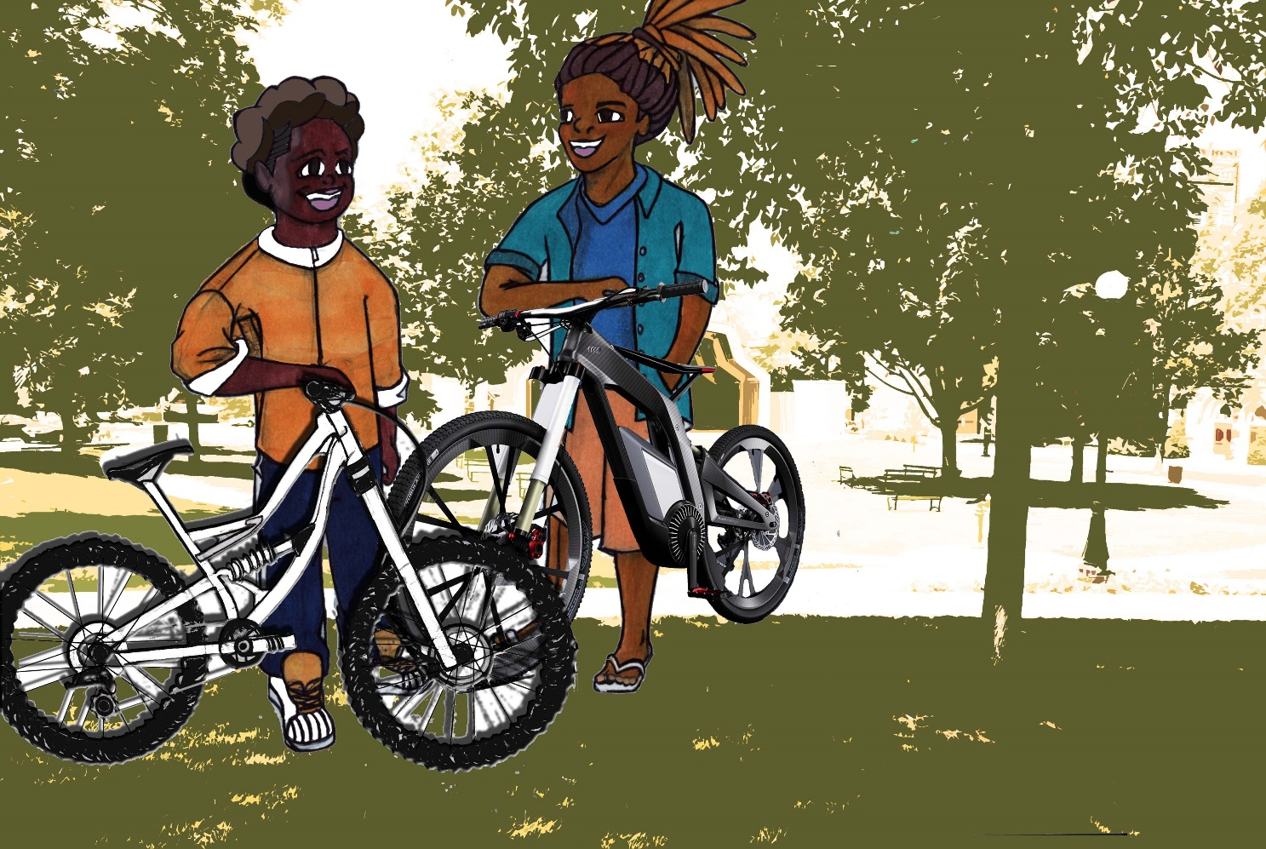

Kofi gave Simeon a raised eyebrow look and asked Simeon, “You fell off that bike and banged your head on the way here, didn’t you? I would beat your bike in a race”.
“Kofi’s right Simeon” some of the kids said, in agreement with Kofi’s opinion.
“Kofi your bike looks alright but we all know my bike’s faster AND looks better”, said Simeon.
“I definitely know for sure, you banged your head on the way here”, Kofi said laughing.
“Whatever man”, Simeon replied.
“You two should race”
“Yeah, see whose bike is the best” some of their friends started saying. Simeon and Kofi both liked the idea so they agreed to a race.
A race course through the park was decided on. The two competitors would race five laps around the edge of a grass covered patch in the park.

Both competitors pulled up to the starting line. Someone shouted, “GO!” and the race started. The bikes set off chains whirring, the tyres kicked up clouds of dust.
Within seconds Kofi gained a small lead and Simeon was trying hard to keep up.
Towards the end of the second lap Simeon closed the gap on Kofi’s lead. By the time the two competitors reached the last corner of the second lap, Kofi’s lead was almost gone. Kofi turned into the corner first. Simeon, practically a hair’s breadth behind Kofi, went speeding into the corner causing his front wheel to obstruct Kofi’s back wheel as the wheels brushed against each other. The collision affected Kofi by slowing him down, this helped Simeon cancel Kofi’s lead. The competitors came out of the bend neck and neck. Simeon took the advantage and pedalled harder, the fox 1000 seemingly let Simeon glide ahead to the lead.
Simeon was able to increase his lead on the remaining laps.

The race reached the final lap, with Simeon having a slight lead. Going into the last corner of the lap Simeon glanced back only to see that his lead was now almost gone, Kofi was right behind him. Simeon, alarmed by this, reacted and steered to block Kofi in at the inside of the bend. Kofi almost managed to squeeze through the closing gap and take the lead but the bikes collided, causing them to shake and wobble. This made it difficult for the riders to keep their balance. Both riders only option was to slow down to regain their balance. Fortunately for Kofi he regained his balance quickly. Simeon on the other hand was struggling to regain his, so he was forced to brake longer and pedal slower. The collision slowed Simeon more so than it did Kofi. Kofi pedalled harder and picked up speed allowing him to pass Simeon as they came out of the bend. Kofi was now in the lead with a clear path to the finish line. Kofi took the advantage and pedalled hard to the finish, winning the race.

The group of friends congratulated the winner, and had some words of consolation for Simeon. Simeon and Kofi shook hands and agreed on a rematch for the next day.
Simeon made his way home disappointed, but the thought of a rematch eased the feeling slightly. As Simeon made his way home he decided he would get to the park early the next day to get in some practise, his thoughts were suddenly interrupted by his stomach which started to make rumbling noises. Thoughts of the rematch for tomorrow were now temporarily forgotten, with thoughts of his hunger and what mum had cooked for dinner on his mind.
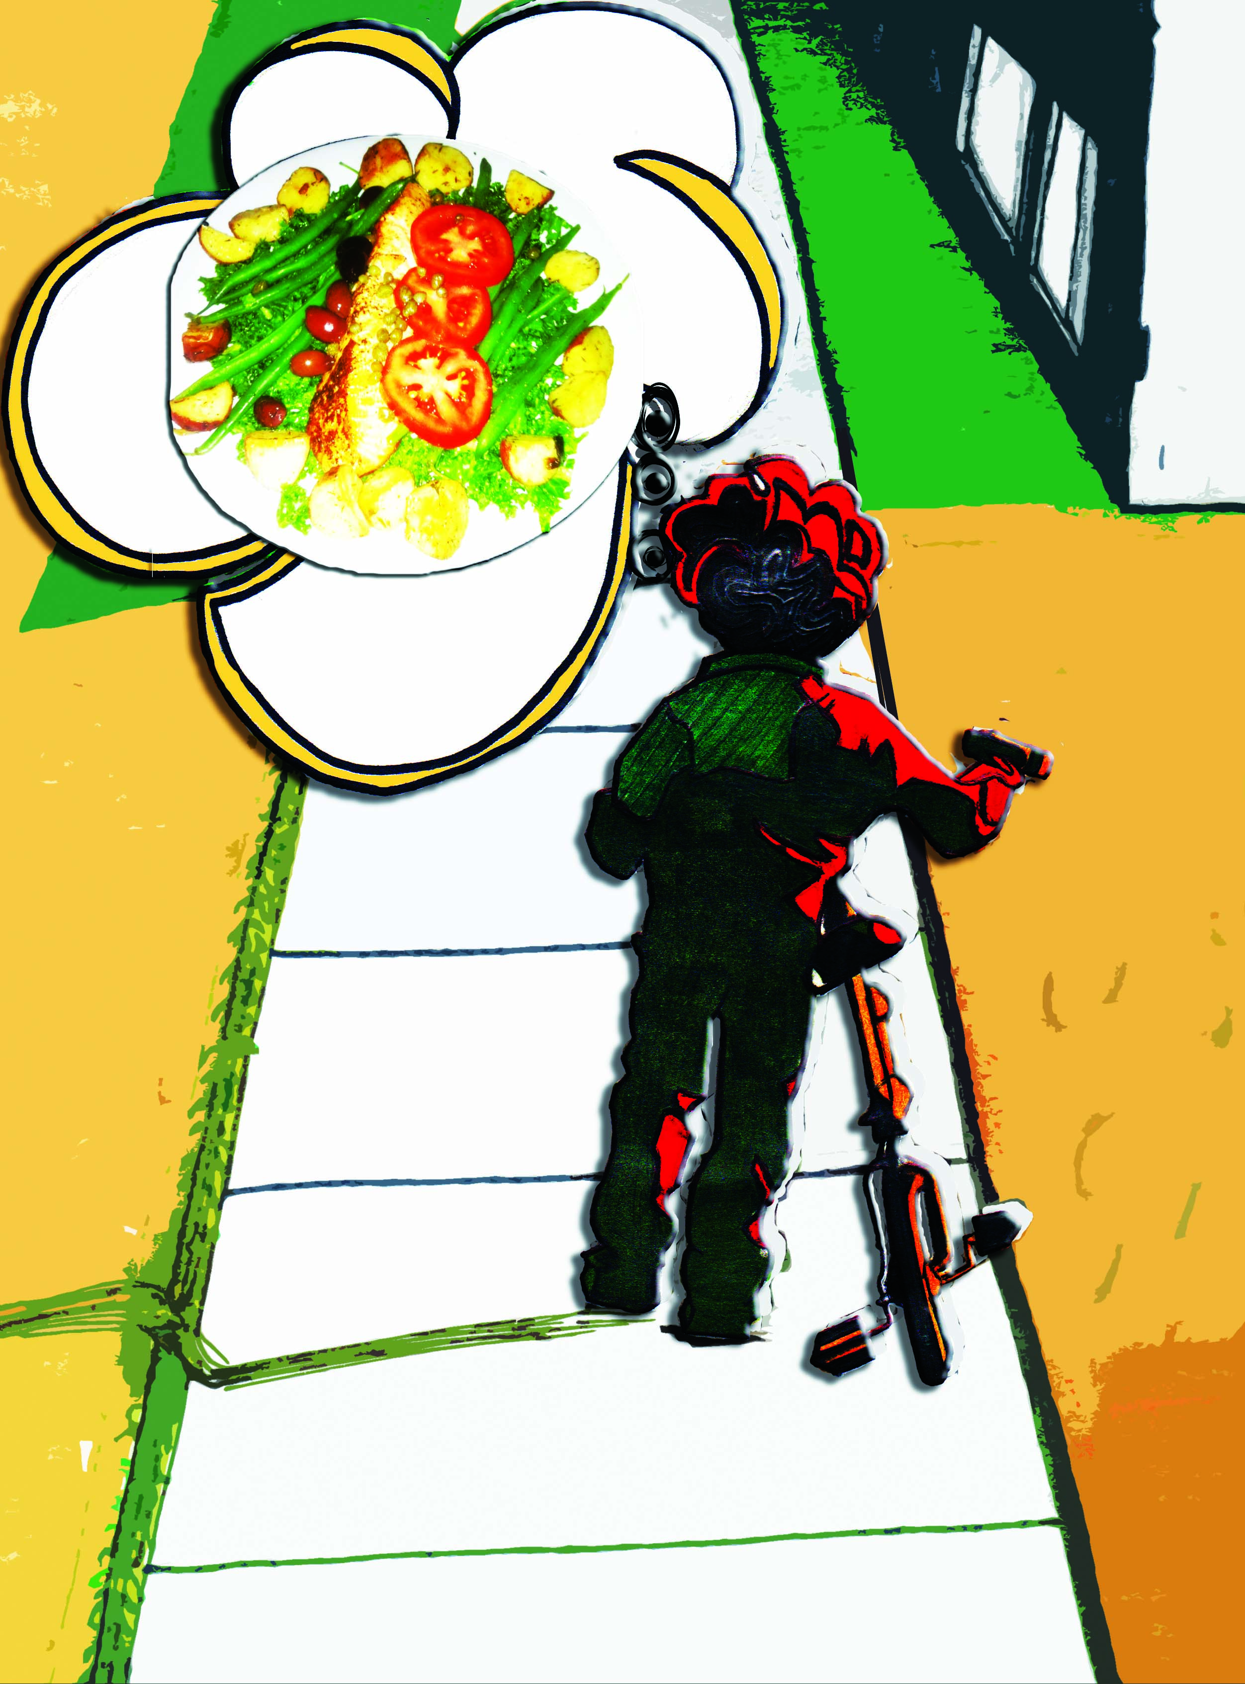

The End

For more short stories, please visit:

www.simeoncan.com

Author: Bukky Omotoso | obukky@hotmail.com | www.simeoncan.com
Illustrator: Robin Baxter | truexpressionist@gmail.com | www.rsbexpressions.tumblr.com
Copyright © 2013 by Bukky Omotoso
All rights reserved.

