Simeon was on a plane with his mum and sister, Sylvia, flying to America. All three were excited about the journey. America was a place they had seen numerous times on TV screens. The family were on a trip to visit the White House and meet the president of the United States of America. The visit was a school trip organised by Sylvia’s school for a group of students who took part in a poetry writing competition. The trip to America was the top prize.

After some hours flying, the plane landed at the airport, the family picked up their luggage then made their way to the hotel. The family were exhausted after such a long journey and decided to have an early night as the trip to the White House was the following day and they would need an early start to get ready for a busy day.

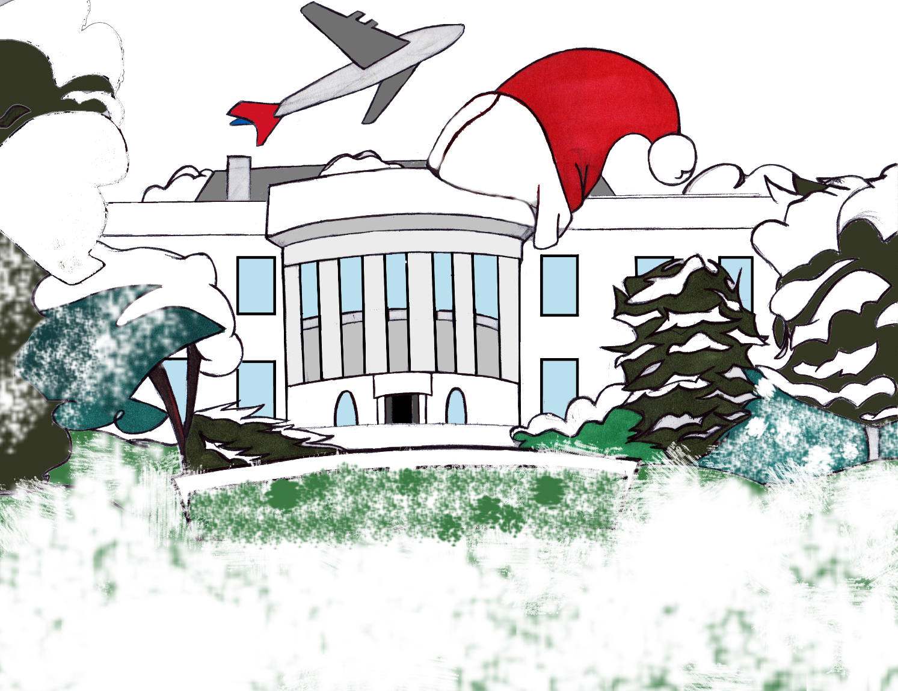

The family woke up the next day to a cold and icy winter morning outside. Sylvia, Simeon and mum started preparing for their visit. Mum co-ordinated and directed the morning’s preparations with military precision, she wasn’t going to leave the room until she was satisfied they were all looking extra well presented, as they would be meeting the President of the USA. Once mum was satisfied all preparations were complete, they left the room and started on the journey to the White House.
Some time later the family arrived at their destination along with the other competition winners. At the gates of the White House the group were greeted with a sparkling smile by a friendly tour guide, who would be showing them around the White House building, prior to their meeting with the President.
It was a busy day at the White House that day. Crowds of people were queuing up to tour, television crews were filming and journalists from different parts of the world could be seen in every direction. The journalists and television crews were all there for a speech the President was due to give that day.

Sylvia and Simeon felt the warmth as soon as they stepped inside the White House building. The weather outside was cold as ice. A short while into the tour Sylvia told mum she needed the toilet. Mum spoke to the tour guide and found out the directions for Sylvia. Simeon decided he also needed to go, so mum repeated the directions to both kids and told Simeon to take his sister with him.

A while later Sylvia stepped through a door into a long corridor, she looked down the corridor for her brother but couldn’t see him anywhere. She guessed he had probably not come out from the toilets yet and she would have to wait for him.
While waiting for Simeon, Sylvia walked down the corridor towards a window on the wall opposite to the door she came through. Looking through the window Sylvia noticed a cat outside in the cold, snow and ice covered, garden. The cat seemed to be stranded on a patch of frozen pond in the White House garden. Sylvia’s thoughts and feelings were gripped with how to rescue the poor animal from its predicament. She looked around for her brother again. Simeon as if on cue walked out into the corridor. She ran up to him pulled his arm and almost dragged him to the window.
“Look outside can you see the cat, I think it’s stuck,”
“No it’s probably just playing, it’s fine,” Simeon replied.
“No it’s not, look at it!” Sylvia insisted “At least let’s go and make sure it’s fine”.
Simeon reluctantly agreed. When they got outside they could see that the cat was wet and trembling from the cold and it looked tired and weak. They quickly realised that the cat had probably tried to leave the pond but fell in. It could have been stuck out there for a while they thought. They felt they had to get the tired-looking cat back into the warm building, the poor animal was probably hungry as well.

The kids surveyed the surroundings of the pond, which was large and probably quite deep. The ice was thin, so there was no easy way for Simeon or Sylvia to rescue the cat from its situation, without almost certainly getting wet and colder than they already were. Walking on the ice to rescue the cat was not an option. Luckily, next to the pond was a large old tree with thick branches. Sylvia looked up at the tree and pointed out a piece of branch which she asked her brother to break off. The idea was for the cat to climb onto the branch and get lifted to safety.
Simeon stood on the edge of the pond and stretched out his arm whilst holding out the piece of branch, but the cat couldn’t grab on to it. Simeon stretched out further but still couldn’t reach close enough.

Sylvia and Simeon decided the best option would be for Simeon to lay on the cold ground, which was covered in snow and ice, with his body overhanging the edge of the pond, while holding out the branch. The idea was daring but gave Simeon the extra length needed to reach the cat with some safety. Simeon lay on the ground and cautiously edged forward over the pond’s edge as much as he could. Sylvia then handed him the piece of branch. He stuck out the branch which the cat grabbed on to instinctively. Simeon began straining as soon as the cat climbed on the branch. The weight of the wet cat nearly caused Simeon to drop the branch plus cat into the freezing pond.
The branch began to slowly bend under the weight of a cold soaking-wet cat. Simeon called out to his sister for help. Sylvia quickly came to lay on the floor next to her brother, and grabbed on to a part of the branch she could safely reach. Together they were able to support the weight of the cat on the piece of branch. The branch bent further till it made a cracking sound.
“Ooops I think it’s going to break,” said Sylvia.
“Ok ok after three throw the branch up in the air towards the garden” said Simeon,
“ok,”
“Threeee!” Shouted Simeon, skipping one and two on this occasion.
The combined strength of the two kids proved to be up to the task. They threw the branch, with cat on, up in the air, the cat flew off the branch twisting like a corkscrew towards the snow and ice covered ground. Flying through the air the cat cried out a long and fading “meoooooooow”, before it landed on its bottom, sliding around on the icy ground, front paws up in the air. The cat came to a gentle stop and dizzily snapped back on to its four paws without its usual sharpness, on the cold icy ground, then immediately shook the icy water of its coat. Sylvia cheered as she stood up. Simeon carefully got up off the ground and dusted the snow and ice off his clothes.
Walking towards Sylvia and Simeon was a lady, who happened to be one of the journalists covering the President’s speech. “Wow good work kids!!” She explained to Sylvia and Simeon that she saw the incident from a window in the corridor.
“What you kids did was soooo brave!” she told them. “Now let’s get back into the building before we all catch a cold,” said the journalist. They both agreed. Simeon put the cat underneath his sweater to keep it warm as they rapidly made their way back into the warm building.

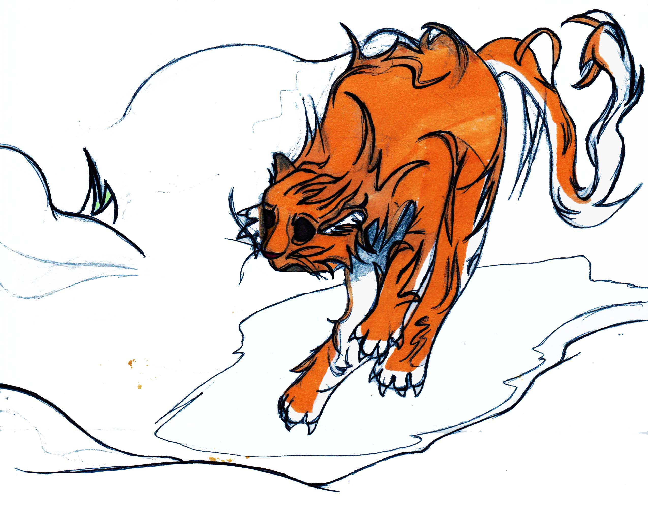
Meanwhile inside the White House, mum and the tour guide were walking down the corridor on their way to check where the two missing members of the tour had got to. Before they reached their destination, they were approached by a man who introduced himself as the President’s assistant. The assistant explained that Sylvia and Simeon were with the President and he would like mum to accompany him to the President’s office. Mum was worried and immediately asked if Sylvia and Simeon were in trouble.
The assistant replied, “they are perfectly fine ma’am, but the president would like to see you”.
Mum was still worried “Why does the President want to see me?” She thought. “Did Simeon go and use the Presidential loo? Oh…I hope Sylvia made it….mmmmmm, she did want to go quite badly”. Mum quickly cycled through every possible toilet related disaster she could think of. Her thoughts were interrupted by the president’s assistant, “Would you please follow me this way ma’am”. Mum followed the assistant.

The assistant held the door open for mum to enter the room where she saw sitting at a table Sylvia and Simeon drinking from mugs containing hot chocolate. “Hi mum”, the kids said in chorus.
A smartly dressed lady and a man, who mum was sure to be the President of America, were sat with the kids. Mum was bemused. “Hello ma’am,” said the President as he walked up to mum. The President being a polite man introduced himself to mum, mum now had no doubts that the man was actually the President. Mum was amazed and not sure what to say. The expression on her face became blank, she looked over at Sylvia and Simeon who smiled back. The President explained to mum how his kids had been searching for the cat all morning and how Sylvia and Simeon had found and rescued the animal.
“They will be happy that the family pet is alive and well…..we were worried,” the President told mum. Towards the end of the conversation with mum the assistant reminded the President that he would be late for his speech. The President agreed, so he told mum and the kids that he would meet with them at the end of their tour, as already planned, but would also bring his wife and children along to meet and thank Sylvia and Simeon specially for rescuing the family pet.

Before the President could leave to make his speech the journalist asked if she could take a picture of the rescuers, mum and the President carrying the rescued pet.
“Just a quick one please,” insisted the assistant. The family quickly gathered for the picture with the cat resting in the President’s arms.
Everyone gave their best smile for the camera. “Cheeeeeeese!” Then the bright camera flash went off. Startled by the brightness of the light the cat sprang up and meowed. As it jumped out of the President’s arms onto the floor, it made a sound which sounded like a fart.
“Excuse me,” said the president with a chuckle.
“I think the cat needs the toilet too,” said Sylvia, everyone in the room laughed. The cat meowed several times then strutted out of the room, probably to begin a new adventure, after thanking its rescuers in its own way.
The President arrived at the podium just in time, the gathered crowd quietened down ready to listen and he started his speech.
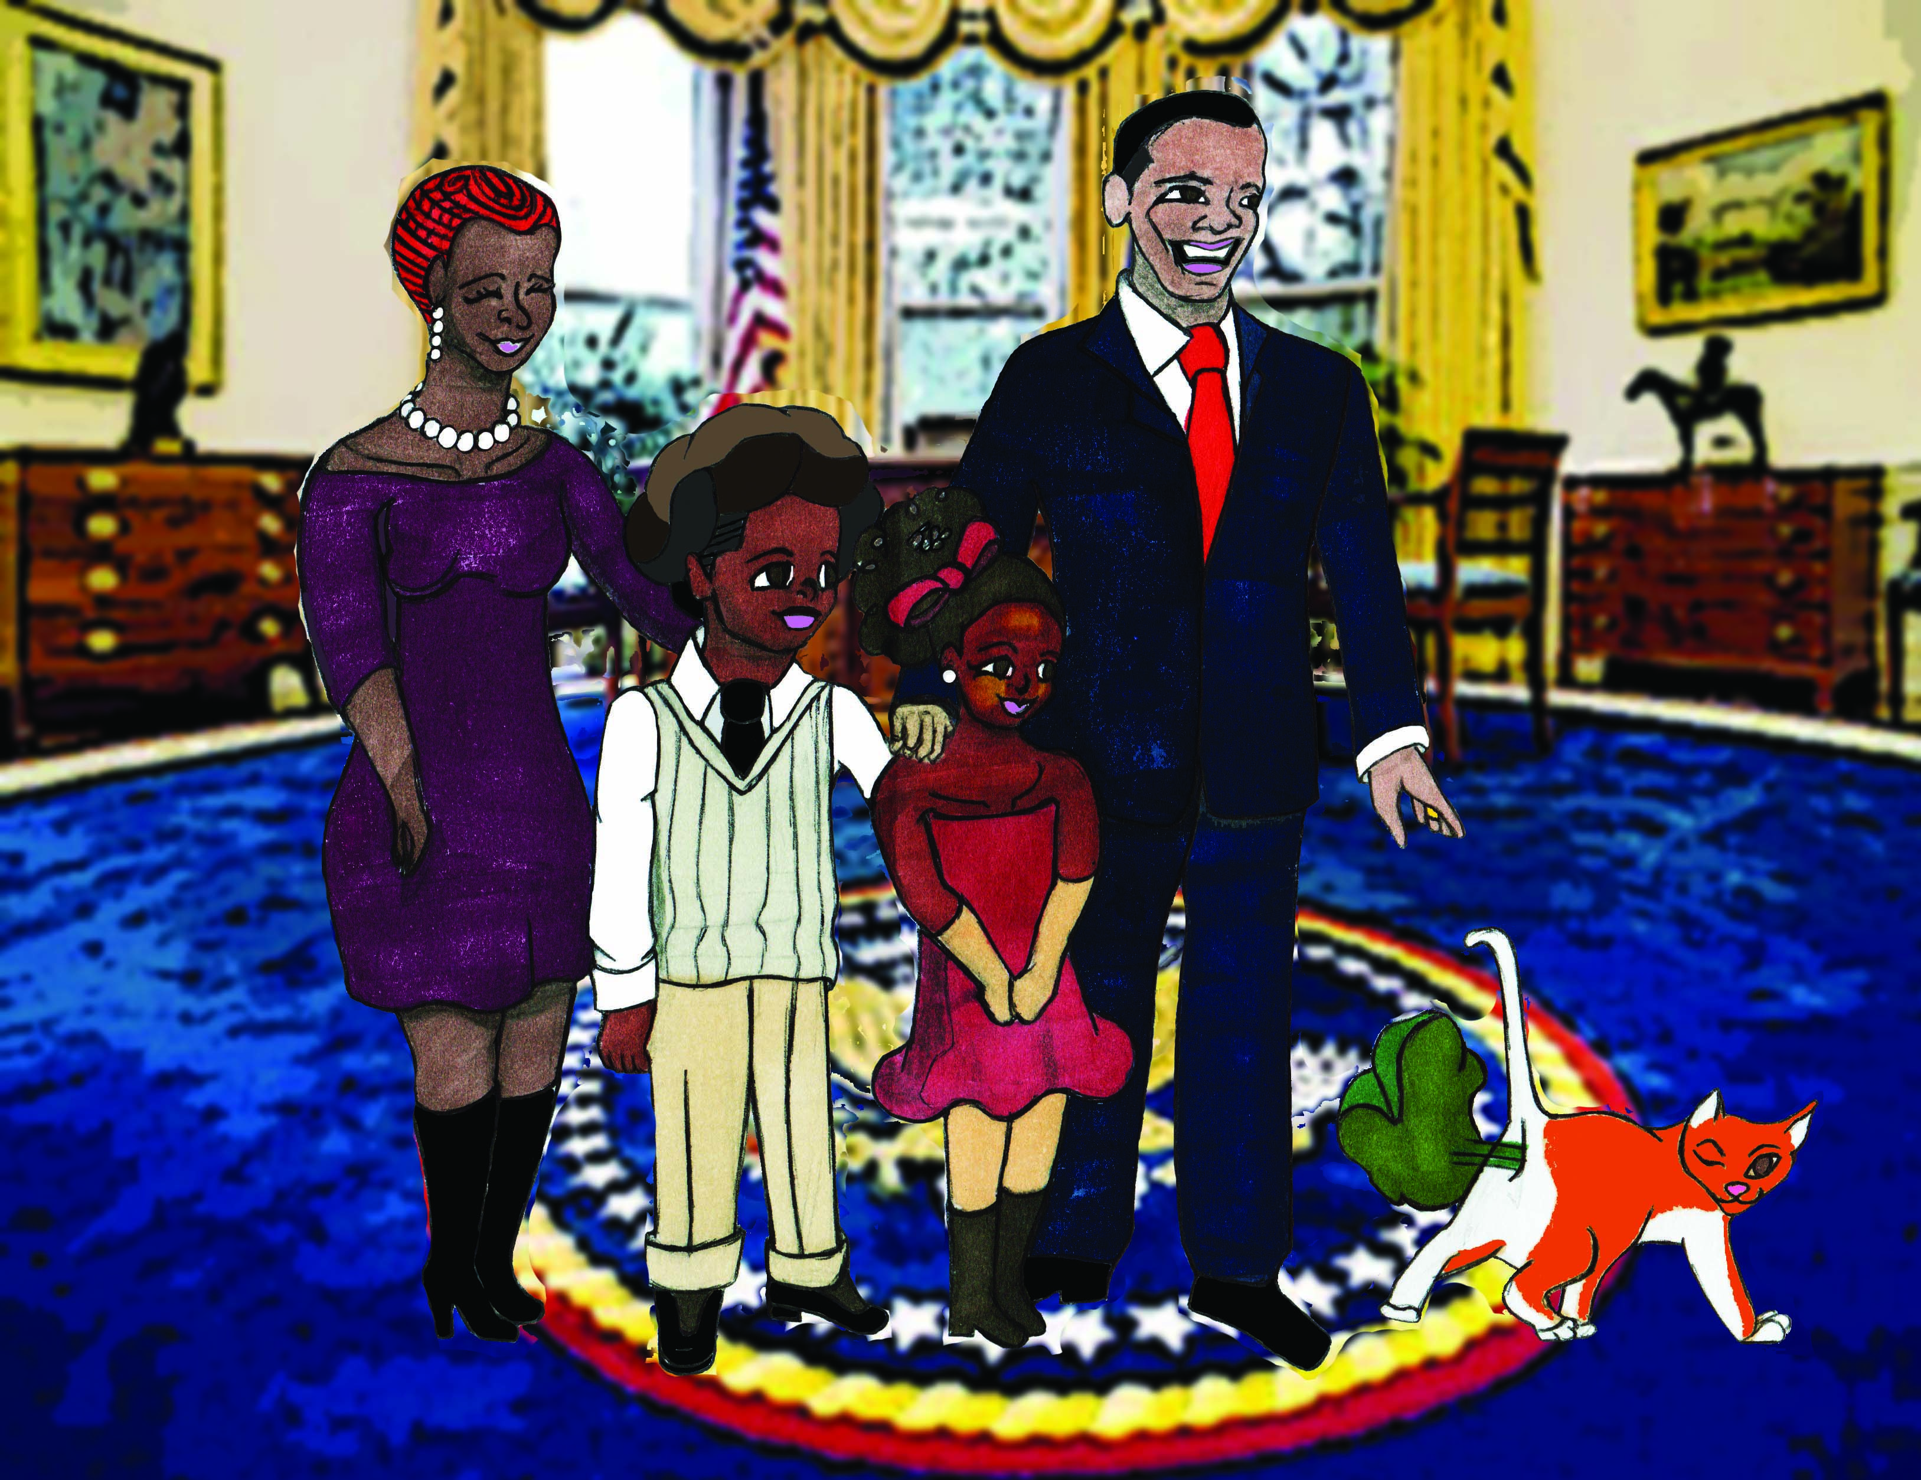

The End

For more short stories, please visit:

www.simeoncan.com

Author: Bukky Omotoso | obukky@hotmail.com | www.simeoncan.com
Illustrator: Robin Baxter | truexpressionist@gmail.com | www.rsbexpressions.tumblr.com
Copyright © 2013 by Bukky Omotoso
All rights reserved.

