“Hey, look what I found today. It looks like a USB memory thing” Simeon pulled out the object in his pocket and showed it to Sylvia.
“Yeah kinda, where did you get it?” Sylvia asked.
“I went to the newsagents bought a few things, came out and I think this fell out my comic”
Sylvia looked at the object in her brother’s hand with curiosity, examining it with her eyes.
“Mmmm… let’s plug it in”
Sylvia took the object from Simeon and inserted it into the USB slot in her tablet. The object fitted into the slot perfectly. Seconds later the screen on the tablet went blank.
“The battery died?” asked Simeon.
“Nah, I think your gadget busted my tablet….”
“You sure? ……Oooops, try switching it on and off”
Sylvia flicked the switch off then on. Nothing happened. She repeated it again. “Crap! It’s busted”
“Try it again and plug in the charger first, maybe the battery IS dead!?”
Sylvia plugged the charger in, flicked the switch to off, paused; then back to on. Simeon looked on anxiously, hoping the tablet would work. The screen flickered several times as the tablet powered on. “I think it’s working…..” Simeon said, in an unsure tone as he stared at the tablet screen. It seemed the tablet was still working.
In a flash, the tablet screen became paper-white then began emitting an unusually bright glow with some faint strands of coloured lights mixed in.
“Something’s happening…….”
Suddenly, before Sylvia could finish her sentence, the object in the slot emitted a blinding white light that filled the entire room. “Whoaaa!!!” said Simeon, as he and Sylvia became enveloped in the blinding glow. The brightness of the light forced Sylvia and Simeon to shut their eyes. The light was not just an intense glow, it could also be felt. It gave Sylvia and Simeon the feeling of being wrapped in the softest largest ball of cotton wool; the sensation was calming and soothing. But the feeling was brief and gradually faded away. This seemed like the signal for the children to open their eyes again.
Sylvia and Simeon opened their eyes to the cue. Sylvia looked at her brother and asked him “Am I dreaming?” Simeon didn’t or maybe couldn’t answer, he wasn’t sure what had just happened, but he knew for sure they were no longer at home in Sylvia’s room.

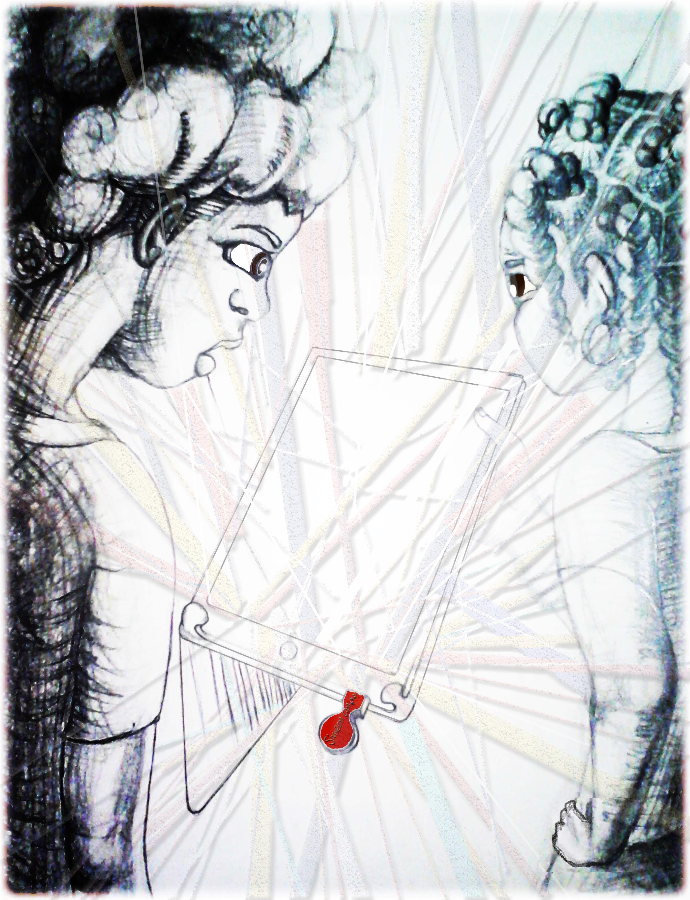

To be continued online…

For more short stories, please visit:

www.simeoncan.com

Author: Bukky Omotoso | obukky@hotmail.com | www.simeoncan.com
Illustrator: Robin Baxter | truexpressionist@gmail.com | www.rsbexpressions.tumblr.com
Copyright © 2013 by Bukky Omotoso
All rights reserved.

