Simeon was in his last class of the day at school, art. The teacher, Ms. Bright, was at the front of the room, desperately trying to address the class. Ms. Bright’s voice was struggling to capture the attention of her students. None of the students were listening to her, plus a seemingly impenetrable wall of noise had formed from the numerous conversations the students were having amongst each other.
In what could later be described as a badly thought out idea, Ms. Bright tapped her desk vigorously with a ruler, trying to gain the attention of the students. Unfortunately, after a tap too many, part of the ruler snapped off, flying at high speed in the direction of Ms. Bright’s nose. The projectile struck her on the nose, causing it to itch and twitch. This caused Ms. Bright to let off a very peculiar high pitched sneeze, “ah ah ah pshooo,” she then breathed out a slow sigh of relief, as her hand touched her chest.
Most of the students saw the incident. None of them could hold back their amusement at their teacher’s mishap and were laughing out loud.
“Quiet everybody, quiet please! And It’s not that funny,” said Ms. Bright. The students who Missed the incident looked around puzzled, wondering what was causing their class mates such amusement.
“What’s so funny?” One kid asked…
“EVERYBODY!!! NOW PAY ATTENTION PLEASE!” Ms. Bright raised her voice sharply in reply. The students quickly quietened down. Some felt sympathetic towards their teacher due to her ruler accident. Ms. Bright’s nose looked sore, as it now displayed a red tint, giving it a clownish appearance.

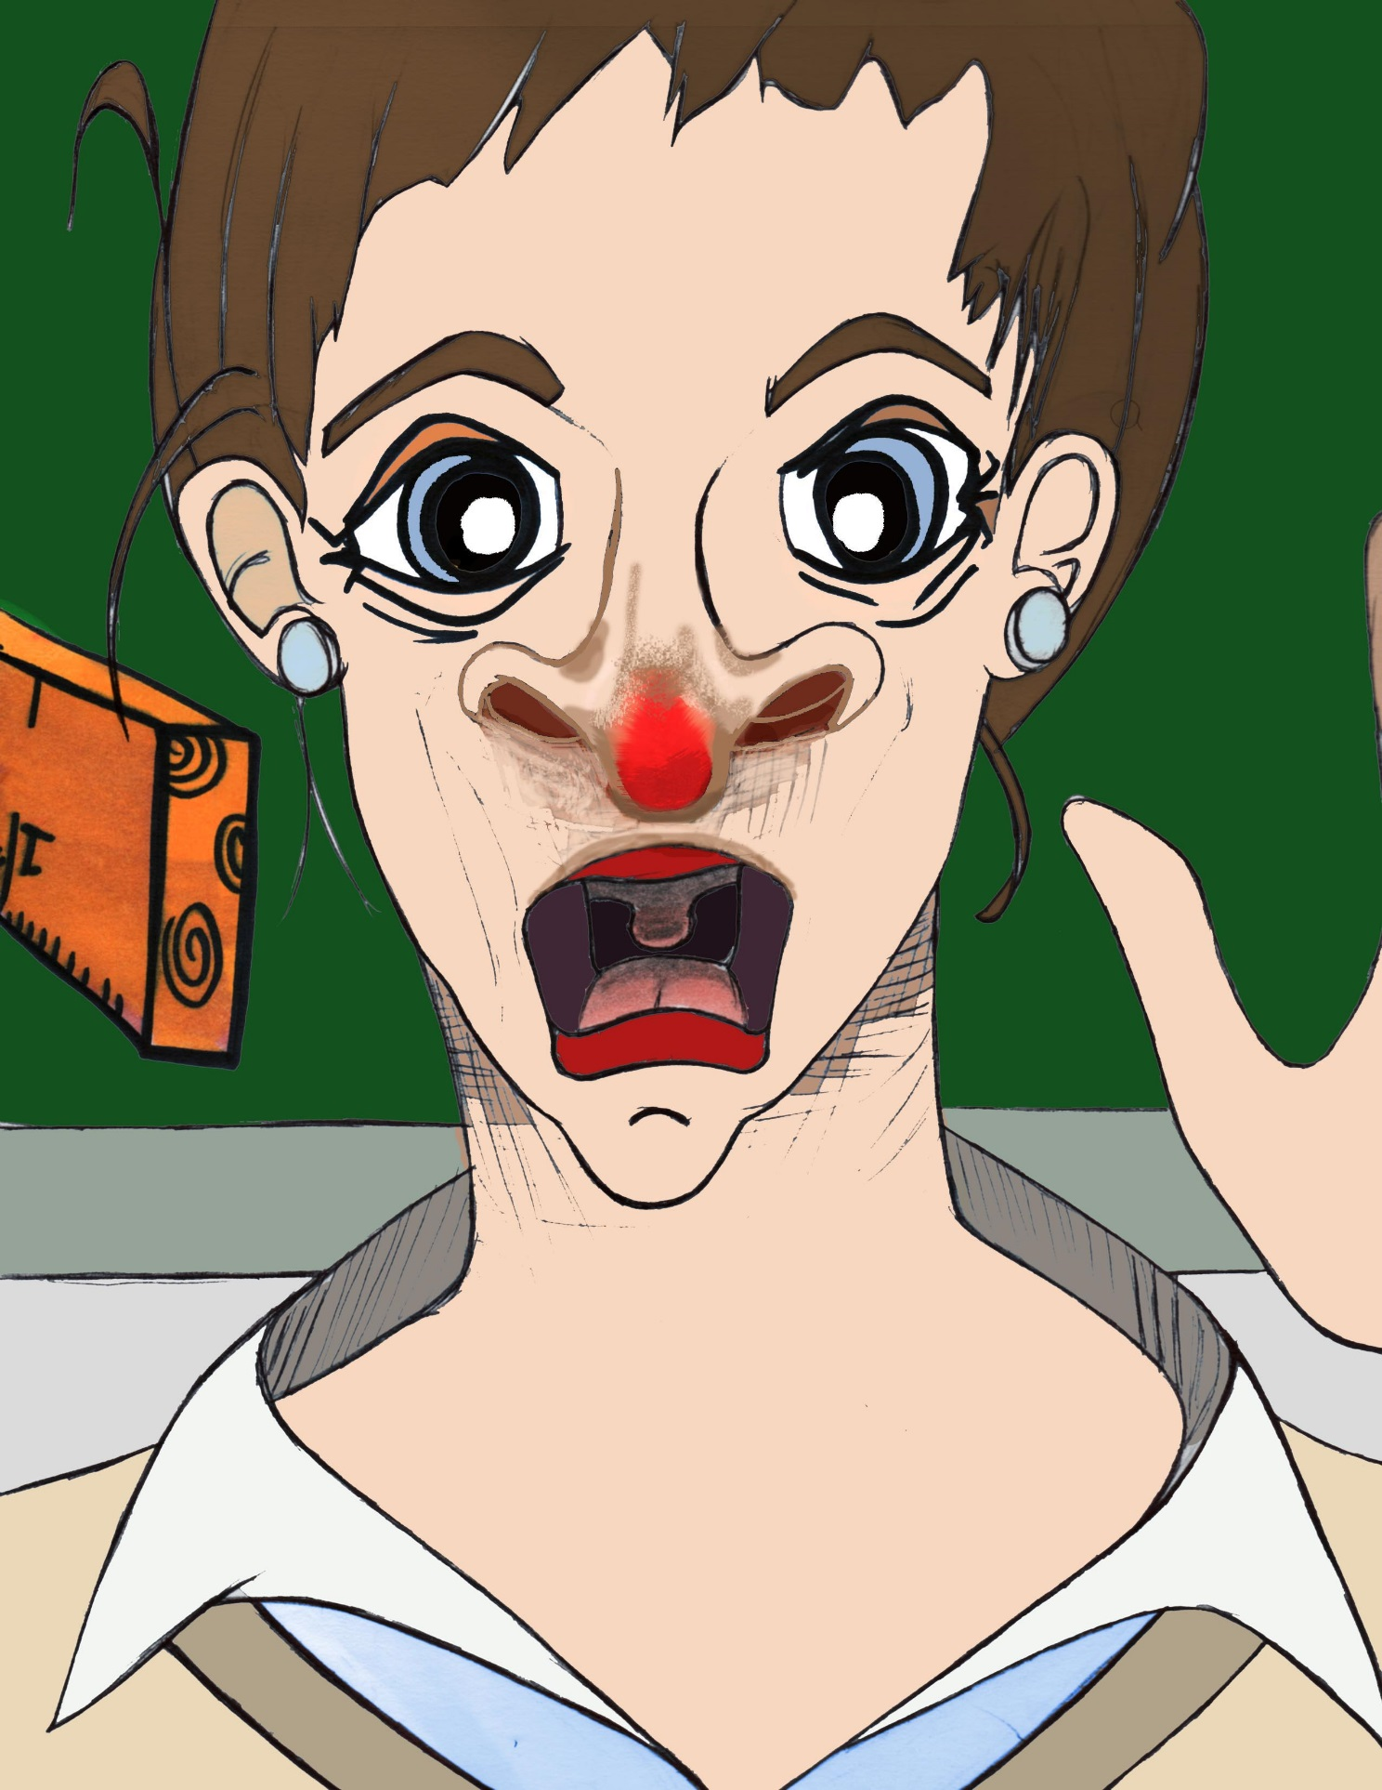

“Class remember the homework assignment, cuttings for a collage on the subject of your choice. Now please clear up the room and wait for the bell”.
Once Ms. Bright finished addressing the class, they all hurried to the task of cleaning the room, clearing away the paints, brushes and other items that were lying around.

The final of a very popular show, “Totally Intensive Training Stars”, was showing on television later. The buzz about the program had been building steadily from morning. All the buzz and excitement was now on pause as the students worked to tidy the art room.

The students were very eager to leave school on the bell. This meant the art room was swiftly made tidy, with time to spare before the bell rang.

Moments later the end of school bell rang and the buzz and excitement was resumed from its pause. The students began an eager and loud rush out of the class room.
“Please remember your homework...” Ms. Bright cut her words short hoping the students heard her message. As they rushed out of the class room discussions on what would be the outcome of the evening’s episode were keenly debated.
“I like Mr Sandman I think the crown is his,”
“No way man!” retorted one of the kids.
“Well it’s gonna be very close but the winner will be...”
“You wish it’s no contest…Disco dude is nowhere near as good as Mr Sandman”.
This was the topic of conversation for the majority of the kids as they made their ways home.

Simeon arrived home to find his sister, Sylvia, already home from school. She was with mum in the kitchen helping to prepare dinner.
“Hello mum, Sylvia,” Simeon said, rushing past the kitchen on his way to his room. Mum replied: “go and get ready for dinner and after dinner we will go through any homework you have”. Simeon rushed through to his room, threw down his school bag and got ready for the rest of the evening.

A while later they all sat down to have dinner. During dinner, mum reminded both children about their homework, and to make sure they cleared up once they finished their dinner.
Time was limited this evening so this meant dinner was over as quickly as possible. Show time was now just some few hours away.
After dinner, Simeon gathered together in his room all the magazines he could get his hands on and began searching eagerly through their pages for pictures he could use for his collage. He chose space travel as the subject. Sylvia didn’t have any homework, so she sat with mum reading magazines and watching TV in the living-room.

Simeon was busy, finding and cutting out useful pictures for his collage. Checking the time he saw that he had thirty minutes before the program began, but the collage wasn’t yet complete, so he continued working as he needed more pictures. By the time he looked up at the clock again he saw the show was about to start. Simeon dropped everything, ran to the living room and sat down in front of the television with Sylvia. Mum asked him if he had finished his homework. He replied he didn’t have much left, and promised her it would be finished as soon as the program was over. Mum reluctantly agreed because he promised.
The program started, the theme tune bleared through the speakers, Sylvia and Simeon sat with eyes fixed on the TV screen.

“Welcome to the final of Totally Intensive Training Stars” the host said, with a perfect smile. The show commenced, the contestants performed and entertained. Sylvia and Simeon seemed to be hypnotised by the proceedings unfolding on the TV screen.
The premise of the show was to accumulate as much points as possible by competing in a number of physical and mental challenges with other contestants. The winner was the contestant with the most points.

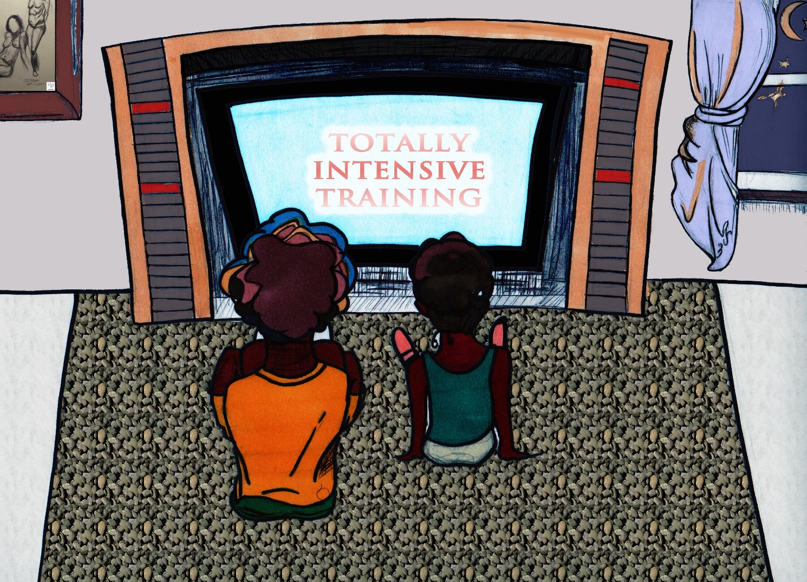

The show kept the attention of Simeon and Sylvia for its entire duration as it reached the final “total intensive training” challenge. This was a physical head to head challenge, involving the last two contestants. Sylvia and Simeon sat still, gripped by the drama of the show. The program continued, the two contestants battled for the crown in a type of jumping competition. During the final challenge Disco Dude sustained an injury which affected his performance. The competition concluded with the other contestant grabbing a fortunate win.
The end credits rolled as Simeon and Sylvia got up and headed for Simeon’s room.
“Make sure you finish the rest of your homework.”
“Yes mum”, Simeon replied.
Both kids were in a daze. Still buzzing from the excitement, drama and entertainment served by the show. In Simeon’s room, Sylvia and Simeon couldn’t resist re-enacting the final challenge of the show by jumping and bouncing on Simeon’s bed. Sylvia threw herself up into the air, “Wooooooooooo, woooooo” she shouted. This was swiftly followed by a tumble into a hard landing on to the bedroom floor. Sylvia let out a scream. “What’s going on in there?!” mum shouted, before entering the room to find Simeon helping Sylvia up.
“What’s going on?!” mum asked as she looked on.
“She fell off the bed mum”. Simeon took his sister’s arm and Sylvia let out another scream. He felt a wet patch on the back of her arm. When he looked at his fingers he saw a stain of blood. Sylvia had a cut on her arm from the fall. Simeon helped his sister onto a chair to make her comfortable. “Let me see,” mum said. She examined Sylvia’s wound then told Simeon to go and get some cotton wool and plaster from a draw in the kitchen. Sylvia was in some pain from the fall. The cut on her arm was still bleeding, so mum took her to the bathroom sink to clean the wound. In the bathroom, mum called Simeon to bring the items she asked for while preparing an antiseptic to clean the wound. Simeon brought the items to the bathroom as instructed, along with a message for his mum.
“Mum dad is on the phone, he wants to speak to you.”
“Ok, you’re gonna have to finish this for me. Sylvia it’s going to sting a bit, ok darling…”. Mum explained to Simeon how to clean Sylvia’s wound with the antiseptic, gave Sylvia a kiss, and then went to answer the phone-call. Following his mum’s instructions, Simeon cleaned his sister’s wound. Sylvia’s facial expressions became irritated before she let out a scream “OW!”
“Sorry, nearly finished,” said Simeon, trying to make sure he cleaned the wound properly. After cleaning the wound, he opened a plaster and placed it over the wound. “Finished now,” he said. Mum returned moments later.
“I’ve cleaned the wound and put the plaster on mum,”
“Great job doc!” said mum, Simeon smiled.
“How are you feeling?” mum asked Sylvia “better now?” Sylvia nodded.
“What were you two doing, pretending to be a pair of Total Intensive Training Stars?” Simeon chuckled. Sylvia gave her mum a slightly quizzical look. “Well?” asked mum. Sylvia was feeling slightly silly and mumbled a low drawn out reply. “Noooooo” said Sylvia.
“Noooooooooo” replied mum, imitating Sylvia. “Is there a yes hiding in that no, ‘cause it’s long like your nose Pinocchio. You’re lucky it wasn’t a worse injury young lady”.
“Go and sit down and I’ll bring you both some ice-cream” Sylvia and Simeon made their way back to Simeon’s bedroom. Mum followed some moments later with their bowls of ice-cream. Simeon ate his quickly, then checked on how his sister was feeling. With a mouthful of ice-cream, Sylvia spluttered, “Better thanks,” so he started on finishing his collage. After Sylvia ate the last spoon from her bowl, she got up from her seat to leave the room. Before leaving she walked over to Simeon at his desk, gave him a kiss then said “thank you”.

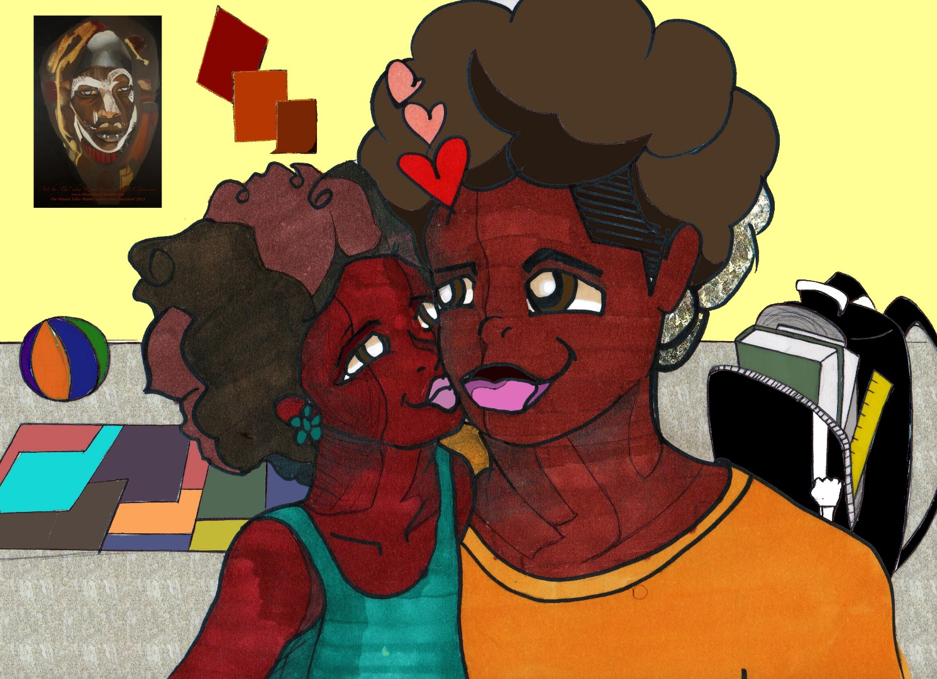

The End

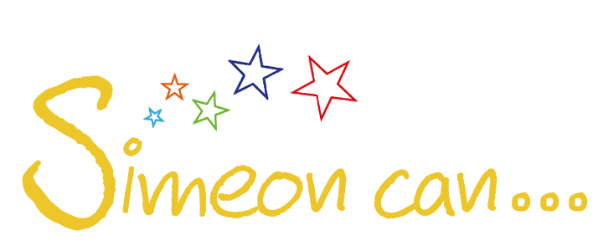

For more short stories, please visit:

www.simeoncan.com

Author: Bukky Omotoso | obukky@hotmail.com | www.simeoncan.com
Illustrator: Robin Baxter | truexpressionist@gmail.com | www.rsbexpressions.tumblr.com
Copyright © 2013 by Bukky Omotoso
All rights reserved.

